**1 .Introduction**

**1.1 Introduction**

This project RTO Management System is developed on Visual basic 6.0 and Microsoft access database.

The project RTO management System is to maintain all records like vehicle registration such as 2 wheeler, 3 wheeler vehicle, heavy vehicles etc. license registration and driving license, deletion of record tax information in each state and many more. These are the activities of RTO office.

We developed this system with fully computerized method to manage all the data.

At present all the records are maintained manually. RTO vehicle registration system is developed and customized for commercial fleet owner and organizations. Its modules support most type of vehicles. With all the data of their respective owner.

This system is easy to understand and easy to interface of system user. It provides user ID and password which is used for data security. By the cause of user ID and password system is used by only the authorized person.

**1.2 Scope Of System**

* Every System has its well defined boundary. Everything inside the boundary constitutes the system. components and all that is outside their boundaries are called the environment.
* System boundary defines the scope of the system, which are other words also defines the system limitations.
* Admin can login and interact with database.
* Interactive approach enables the user to view Taxes on the screen.
* As System is computerized thus time is saved for Entire registration process.
* Personal Id provided, so it maintain security and confidentially.
* It prevents Duplication of work.
* Reduce manual work.
* User friendly.
* User can search record easily.

**1.3 Proposed Of System**

This Project Deals With the Transactions Of RTO Services Office:-

* Registration of Learner’s License.
* Registration of Permanent License.
* Issue of Learner’s License.
* Vehicle Registration.
* Issue of Permanent License.
* Taxation.

The System provides effective utilization of available resources .To Enhance the efficiency and diversification of services activities.

**2.Analysis**

**2.1 Fact Finding techniques**

To first activity in analysis phase is to do the preliminary investigation data collecting is very important for this we can use fact finding techniques.

* **Interview:-**

We use this technique frequently to collect information about current system from the potential user. We choose some people from our surrounding who were either user in some activity related with our project. These help us to understand all stages involve in activity.

* **Record review:-**

This is the most beneficial technique for us while developing my database. We studied existing system, file structures which is used by government and we made our system more user friendly.

* **Observation:-**

While finding the facts we keenly observed all the activities of existing system. We paid attention to the usage of file and documentation, record keeping and the handling of queries in the existing system. Observation helped us in finding out the functioning apart from the ideal or desire.

* **Questionnaire:-**

We used this technique in the initial phase of our project. We conducted this session by asking questions to our friends who recently applied for license. Also we visit to the RTO office to collect some new information by asking some questions.

**2.2 Feasibility Study**

A feasibility study is conducted to select the best system that meets performance requirements. This entails an identification description, an evaluation of candidate system, and the selection of the best system for the job.

A statement of constraints, the identification of specific system objectives and a description of outputs define a system’s required performance. The analyst is then ready to evaluate the feasibility of candidate system to produce these outputs.

1. **Technical feasibility** :- The technical feasibility assessment is focused on gaining an understanding of the present technical resources of the organization and their application to the expected needs of the proposed system. It is an evaluation of the hardware and software and how it meets the needs of the proposed system
2. **Economic feasibility :-** The purposed of the economic feasibility assessment is to determine the positive economic benefits to the organization that the proposed system will provide. It includes quantification and identification of all the benefits expected. This assessment typically involves a cost/benefits analysis
3. **Operation feasibility :**- Operational feasibility is a measure of how well a proposed system solves the problems. The problems, and takes advantage of the opportunities identified during scope definition and how it satisfies the requirements identified in the requirements analysis phase of system development.

The operational feasibility assessment focuses on the degree to which the proposed development projects fits in with the existing business environment and objectives with regard to development schedule, delivery date, corporate culture, and existing business processes.

1. **Legal feasibility :-** Determines whether the proposed system conflicts with legal requirements e.g. a data processing system must comply with the local data protection acts.

**2.3 Hardware & Software Specifications**

**Software Configuration:-**

Operating Platform :- WINDOWS 2000/XP/10

Database :- MS-ACCESS

Software :- VB 6.0

**Hardware Configuration:-**

RAM :- Min 1GB

Hard Disk :- Min 10GB

Processor :- Pentium Processor.

**3. System Design**

**3.1 ER Diagram**

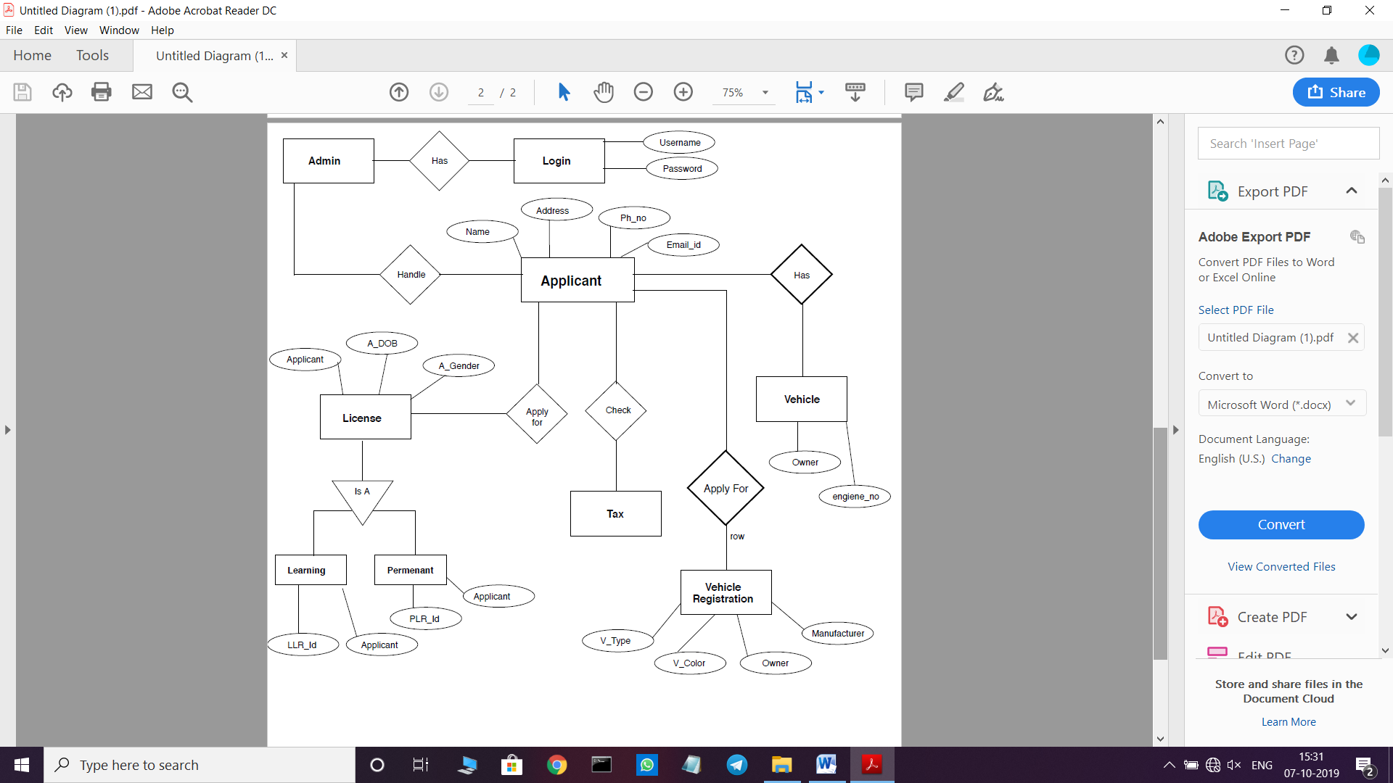

**3.2 Context Level Diagram**

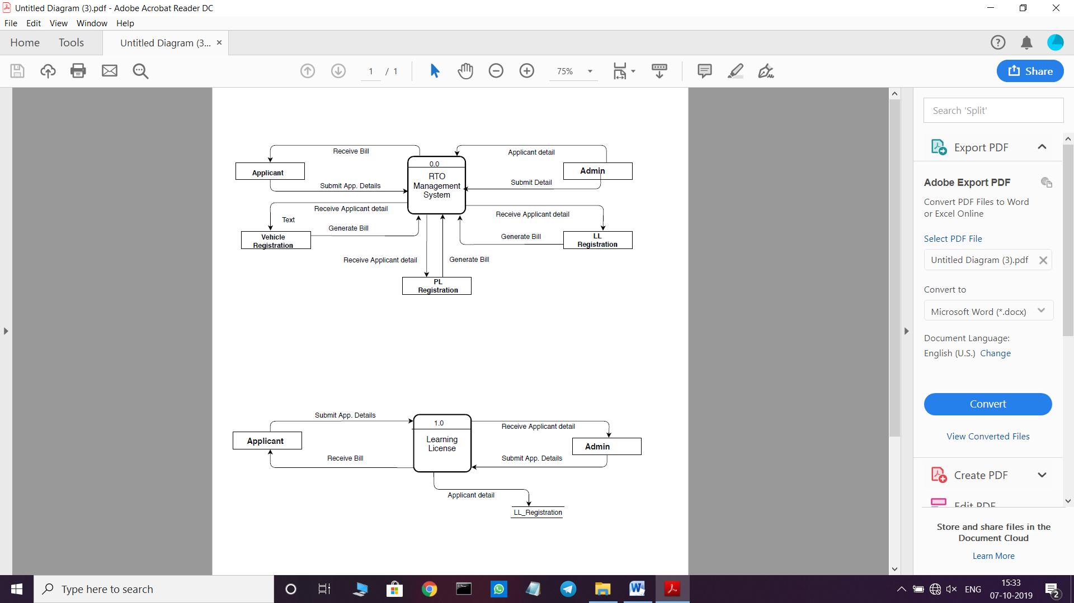

**3.3 DFD**



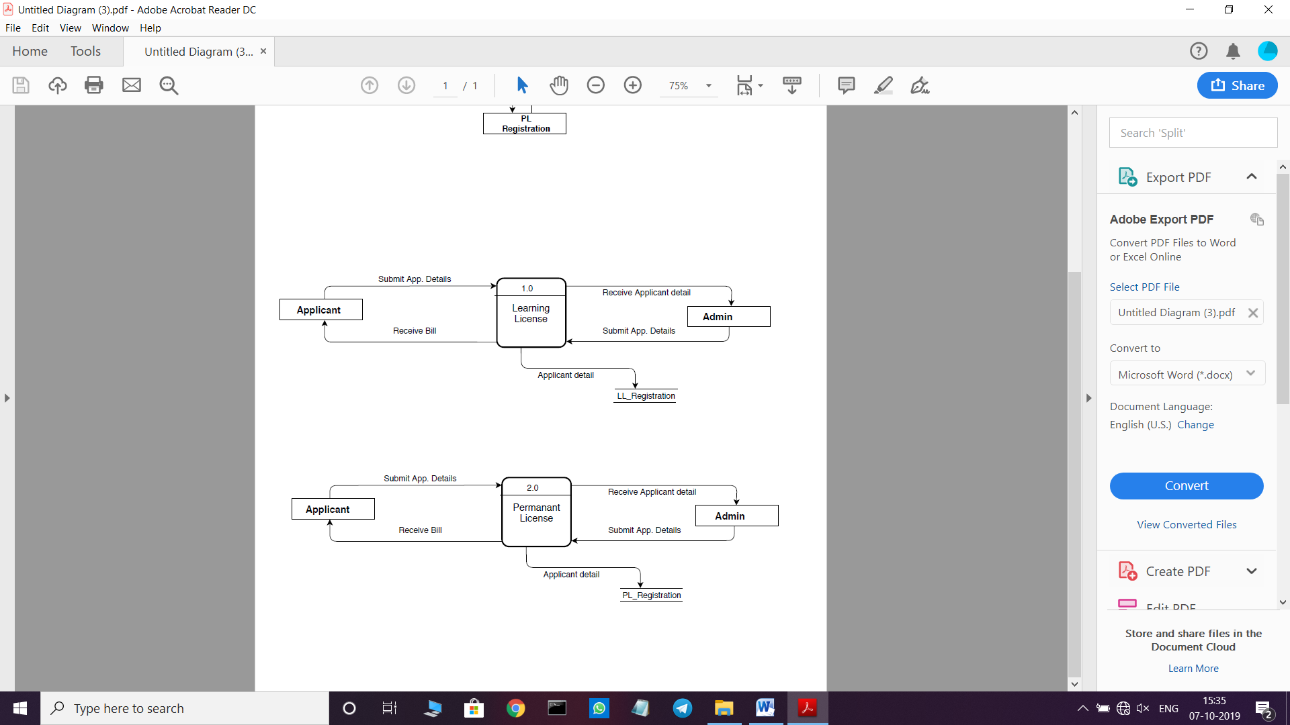

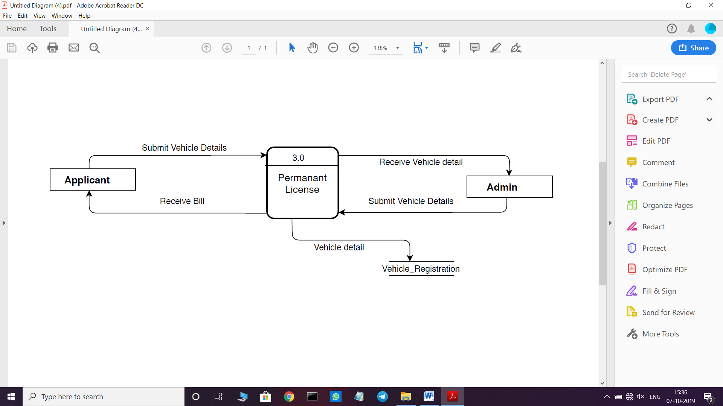

**3.4 Data Dictionary**

**Admin Login**

|  |  |  |
| --- | --- | --- |
| **Field_name** | **Datatype** | **Description** |
| User name | Text | Store’s admin username |
| Password | Text | Store’s admin Password |

**LL Registration**

|  |  |  |
| --- | --- | --- |
| **Field_name** | **Datatype** | **Description** |
| State | Text | Store’s the Applicant’s State |
| Pincode | Number | Store’s the Applicant’s pincode |
| First | Text | Store’s Applicant’s first name |
| Middle | Text | Store’sApplicant’s middlename |
| Last | Text | Store’s Applicant’s lastname |
| Relation | Text | Store’s Applicant’s Relation |
| R-first | Text | Store’s Applicant’s Rel_name |
| R_middle | Text | Store’s Applicant’s Rel_name |
| R_Last | Text | Store’s Applicant’s Rel_name |
| Aadhar_no | Text | Store’s Applicant’s Aadhar_no |
| Gender | Text | Store’s Applicant’s Gender |
| DOB | Date/Time | Store’s Applicant’s DOB |
| Place_of_Birth | Text | Store’s Applicant’s POB |
| Blood_group | Text | Store’s Applicant’s Blood grp |
| Mobile_no | Text | Store’s Applicant’s Mobile |
| Email_no | Text | Store’s Applicant’s Email |
| Identification_mark | Text | Store’s Applicant’s id.mark |
| State_of_applicant | Text | Store’s Applicant’s State |
| District | Text | Store’s Applicant’s District |
| Village/town | Text | Store’s Applicant’s village |
| Pincode_applicant | Text | Store’s Applicant’s pincode |
| Add_line 1 | Text | Store’s Applicant’s address |
| Add_line 2 | Text | Store’s Applicant’s address |
| Add_line 3 | Text | Store’s Applicant’s address |
| LLR_ID | Text | Store’s Applicant’s LLR_ID |

**PL Registration**

|  |  |  |
| --- | --- | --- |
| **Field_name** | **Datatype** | **Description** |
| State | Text | Store’s the Applicant’s State |
| Pincode | Number | Store’s the Applicant’s pincode |
| First | Text | Store’s Applicant’s first name |
| Middle | Text | Store’sApplicant’s middlename |
| Last | Text | Store’s Applicant’s lastname |
| Relation | Text | Store’s Applicant’s Relation |
| R-first | Text | Store’s Applicant’s Rel_name |
| R_middle | Text | Store’s Applicant’s Rel_name |
| R_Last | Text | Store’s Applicant’s Rel_name |
| Aadhar_no | Text | Store’s Applicant’s Aadhar_no |
| Gender | Text | Store’s Applicant’s Gender |
| DOB | Date/Time | Store’s Applicant’s DOB |
| Place_of_Birth | Text | Store’s Applicant’s POB |
| Blood_group | Text | Store’s Applicant’s Blood grp |
| Mobile_no | Text | Store’s Applicant’s Mobile |
| Email_no | Text | Store’s Applicant’s Email |
| Identification_mark | Text | Store’s Applicant’s id.mark |
| State_of_applicant | Text | Store’s Applicant’s State |
| District | Text | Store’s Applicant’s District |
| Village/town | Text | Store’s Applicant’s village |
| Pincode_applicant | Text | Store’s Applicant’s pincode |
| Add_line 1 | Text | Store’s Applicant’s address |
| Add_line 2 | Text | Store’s Applicant’s address |
| Add_line 3 | Text | Store’s Applicant’s address |
| LLR_ID | Text | Store’s Applicant’s LLR_ID |

**Vehicle Registration**

|  |  |  |
| --- | --- | --- |
| **Field_name** | **DataType** | **Description** |
| O-first | Text | Store’s Owner’s name |
| O_middle | Text | Store’s Owner’s name |
| O_Last | Text | Store’s Owner’s name |
| Gender | Text | Store’s Owner’s Gender |
| Mobile_no | Text | Store’s Owner’s Mobile |
| Email_id | Text | Store’s Owner’s Email |
| State_of_Owner | Text | Store’s Owner‘s State |
| District | Text | Store’s Owner’s District |
| Village/town | Text | Store’s Owner’s village |
| Pincode_applicant | Text | Store’s Owner’s pincode |
| V_type | Text | Store’s Vehicle Type |
| V_Color | Text | Store’s vehicle color |
| Chasis_no | Text | Store’s chasis no |
| Engiene_no | Text | Store’s engiene no |
| V_manu | Text | Stores vehicle manufacturer |
| D_name | Text | Store’s Dealer name |
| D_A_NO | Text | Stores’Dealer no |
| D_ID | Text | Stores Dealer’s Id |
| Add_line 1 | Text | Store’s Applicant’s address |
| Add_line 2 | Text | Store’s Applicant’s address |
| Add_line 3 | Text | Store’s Applicant’s address |

**4.Form Design**

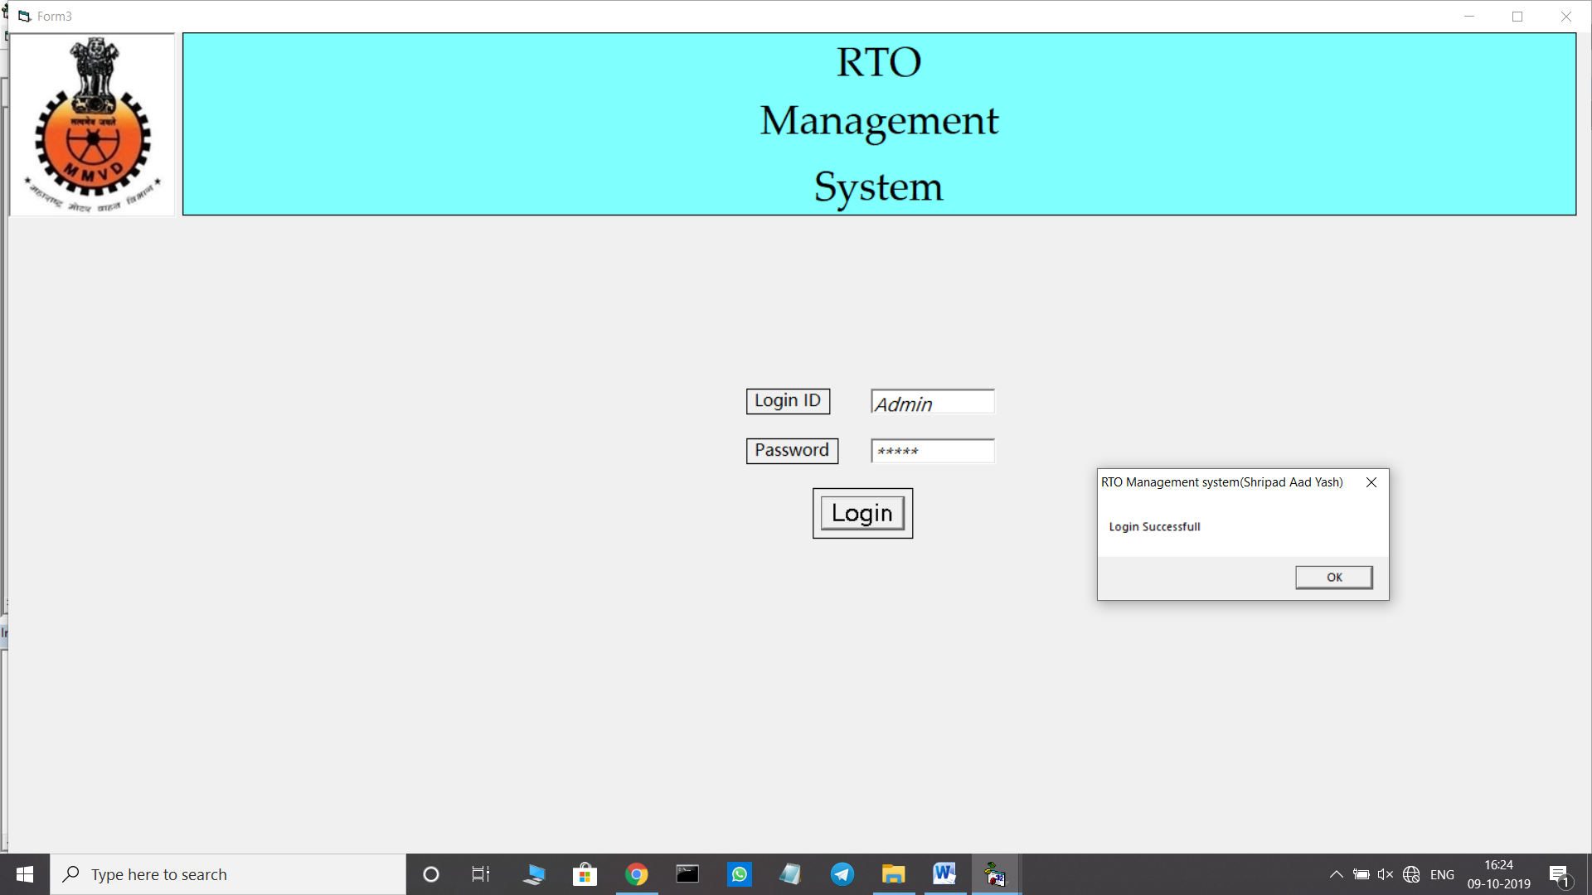

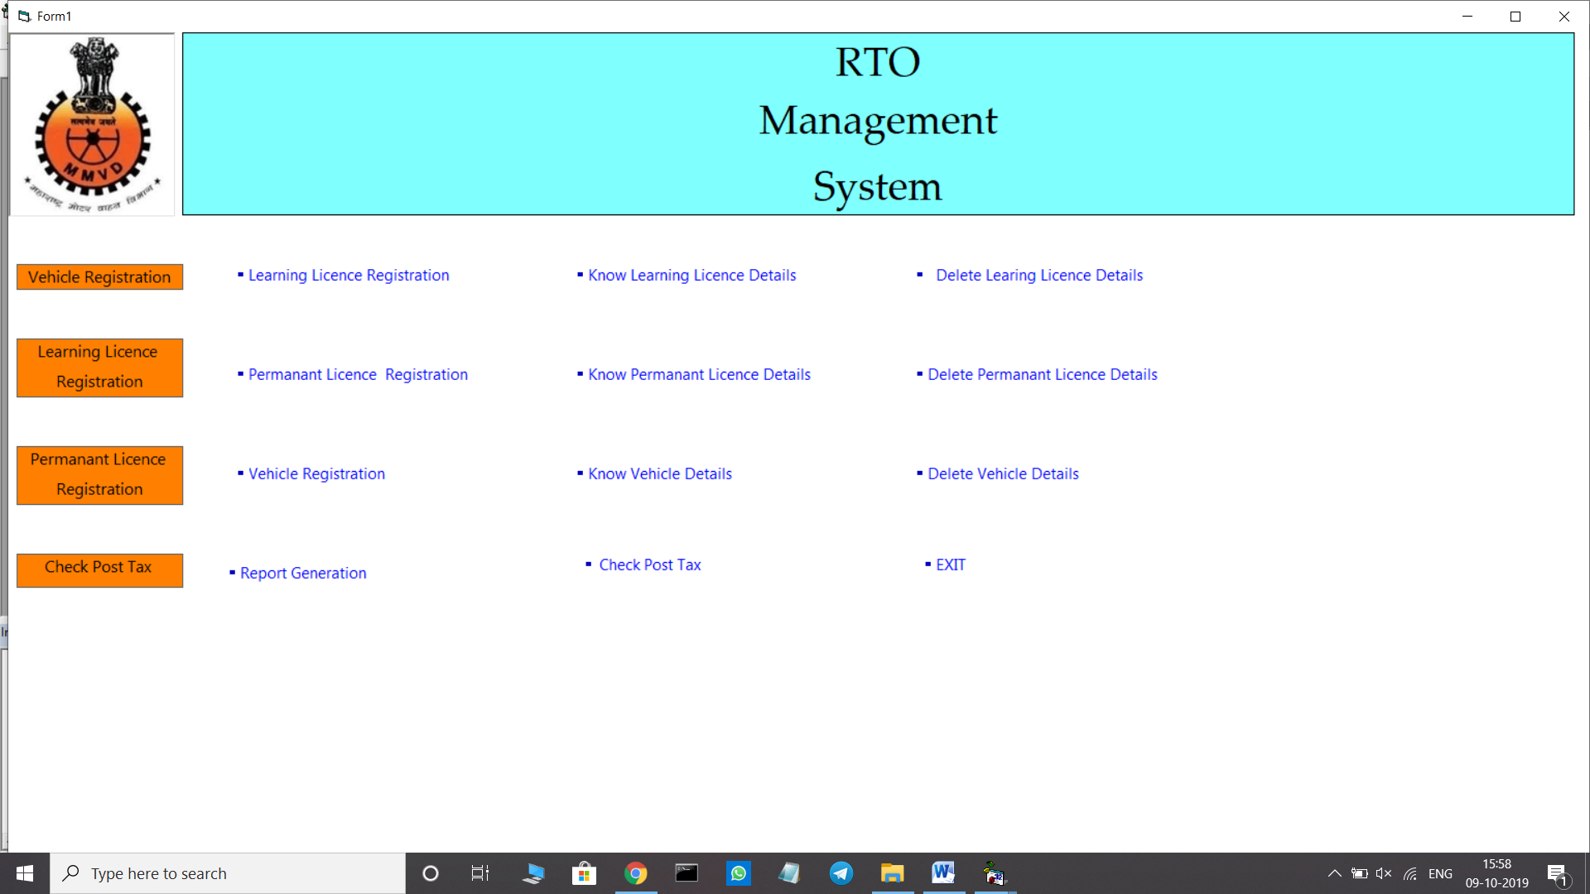

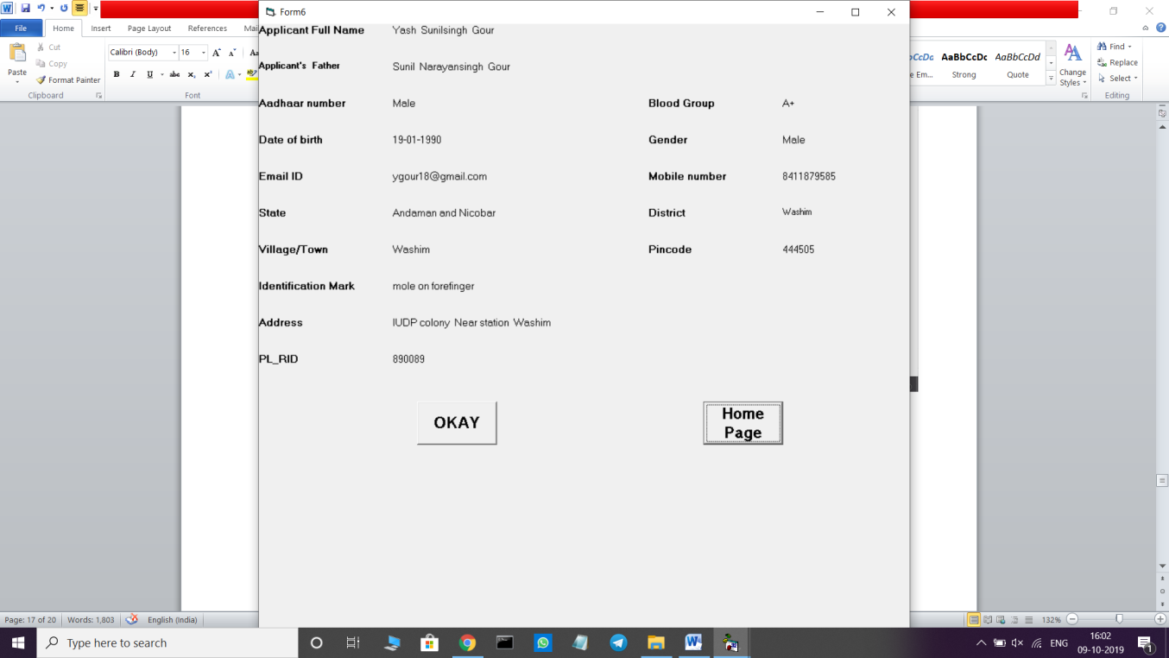

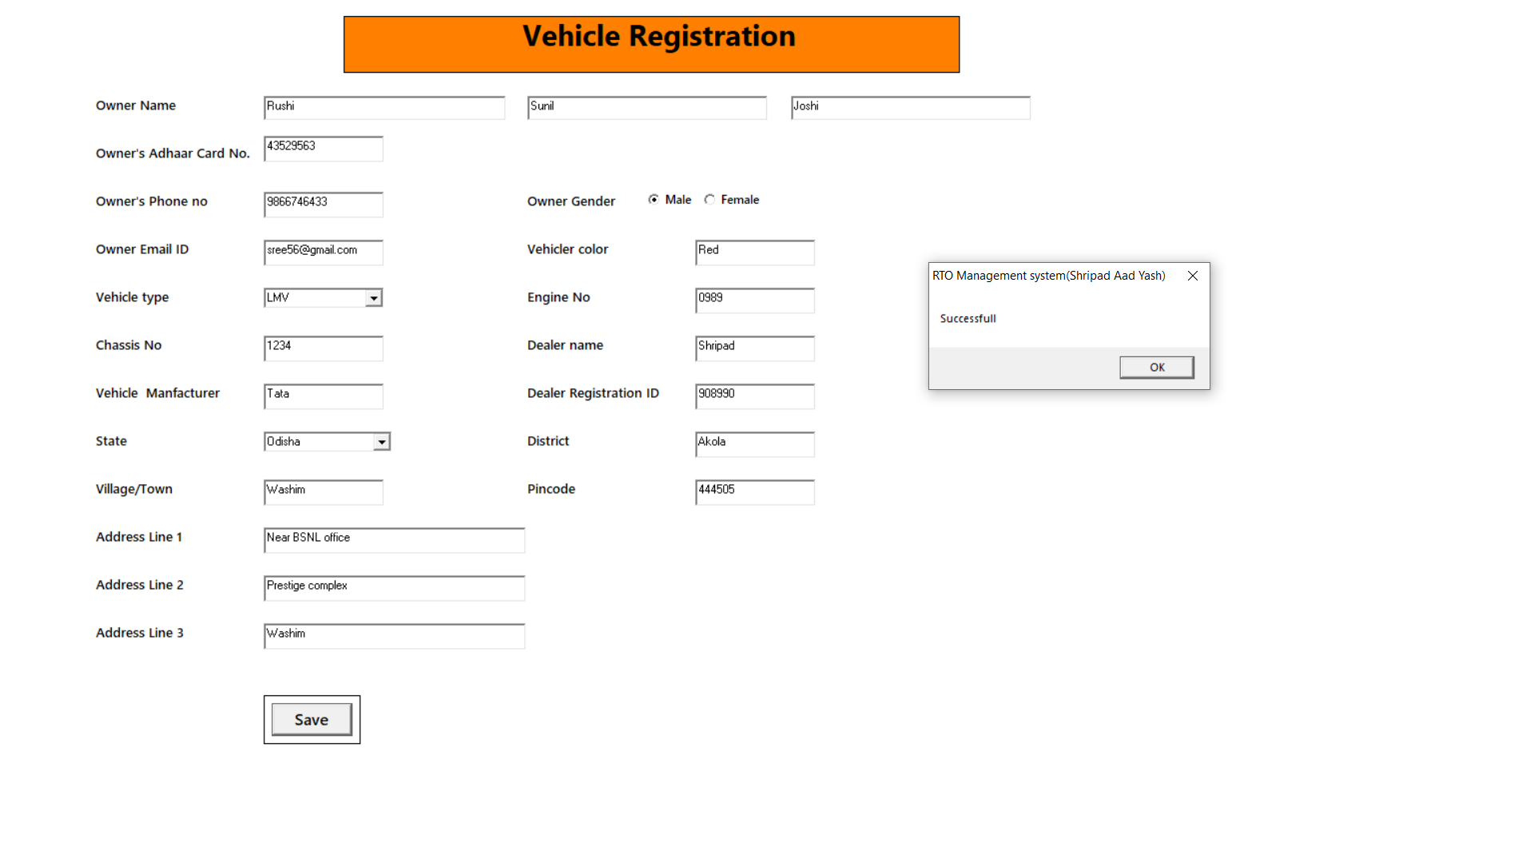

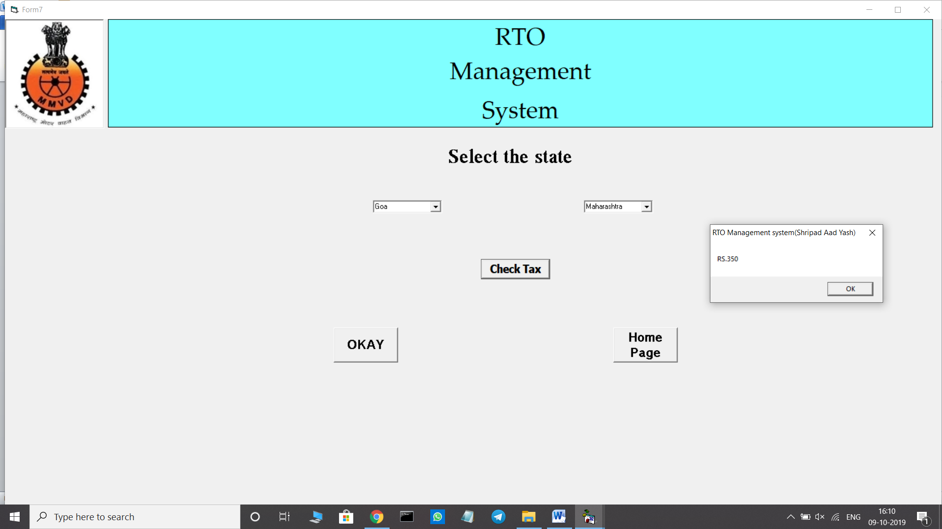

**5.Report**

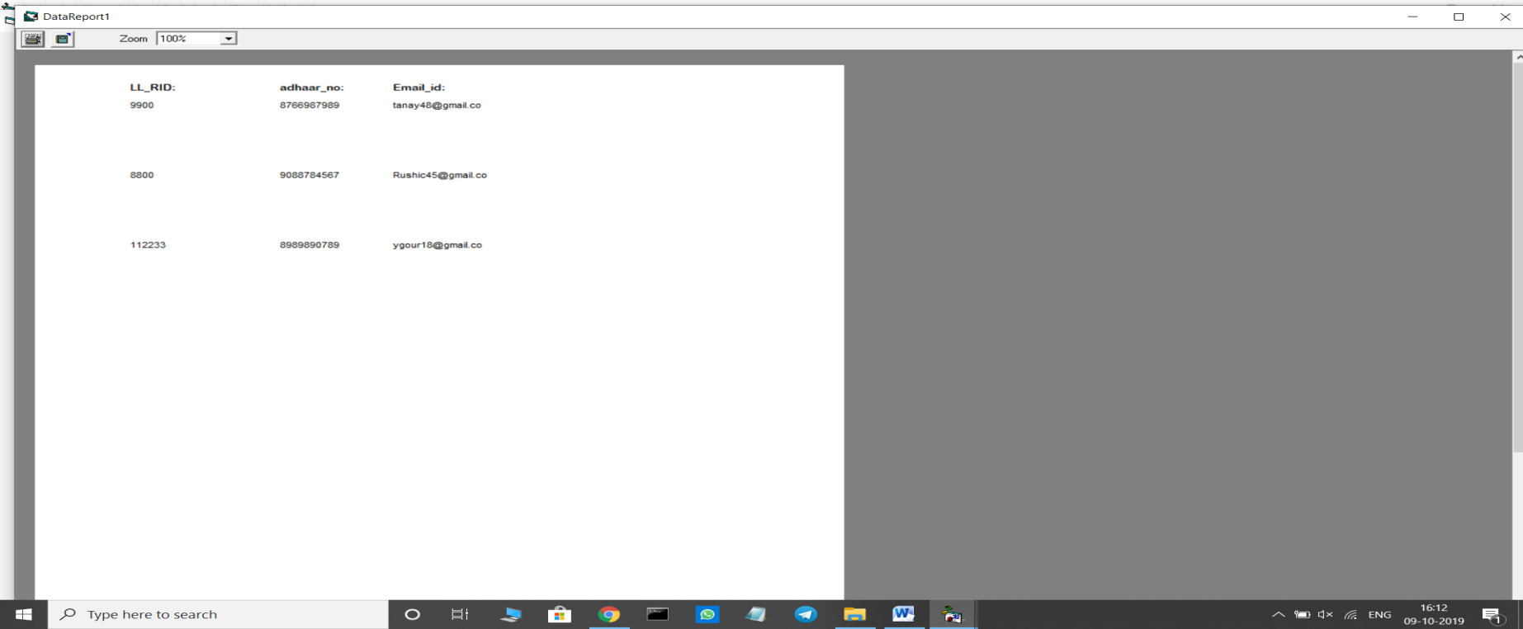

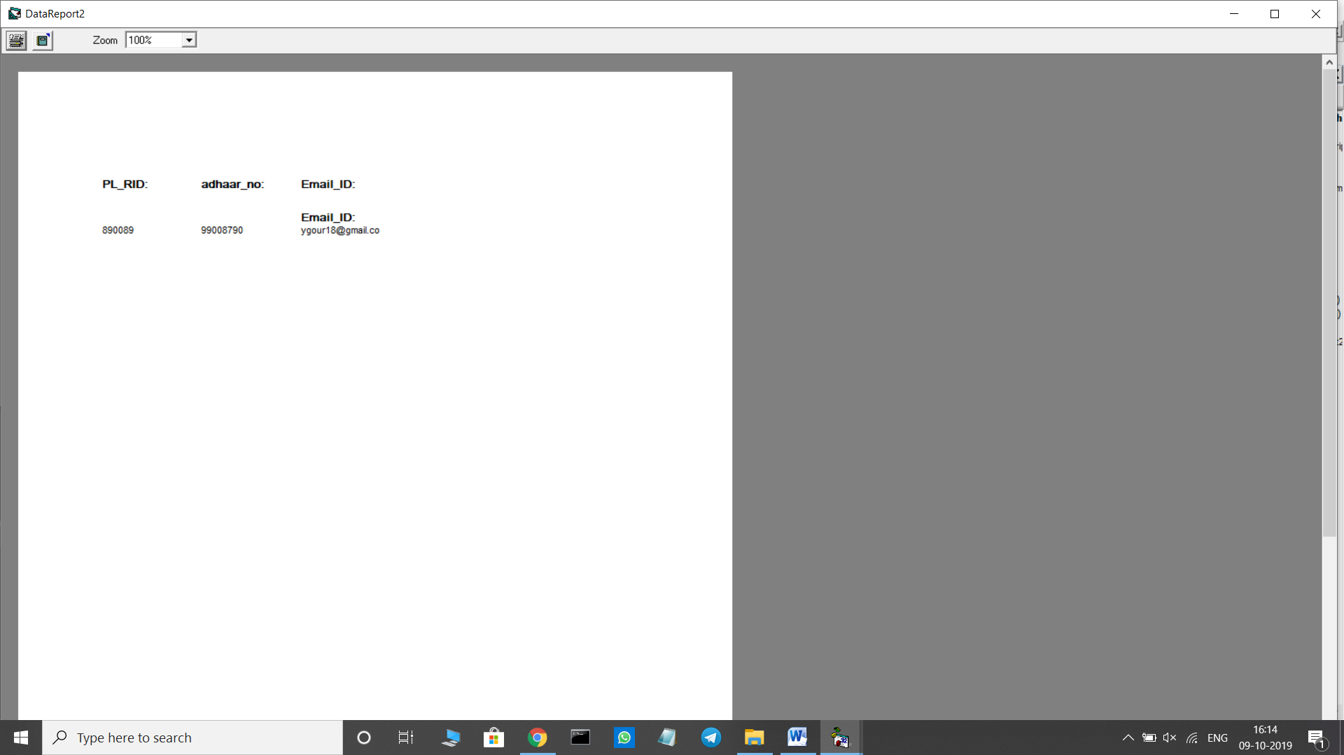

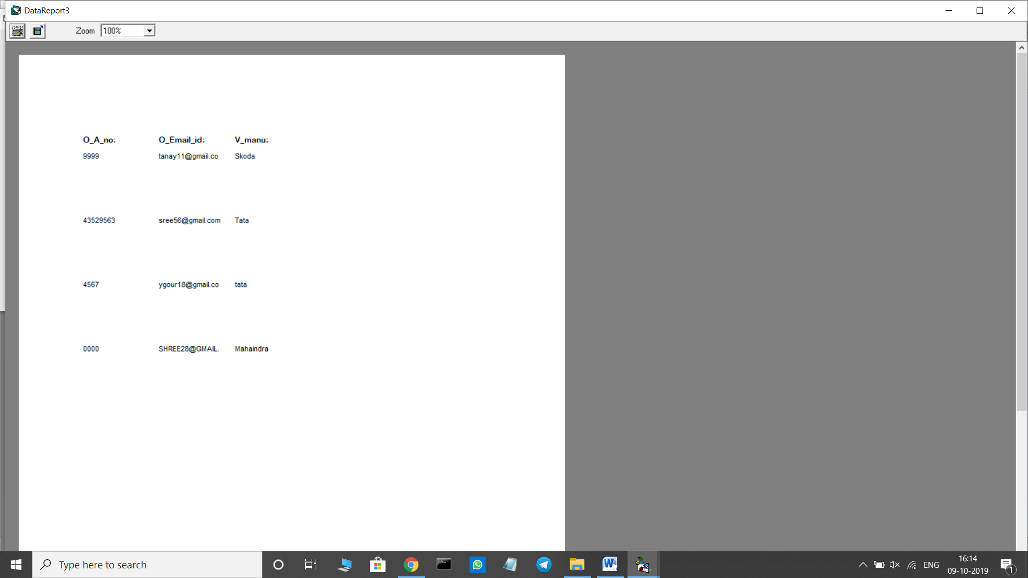

**6. Advantages & Limitation**

**6.1 Advantages:-**

* Has a clearly arranges and users friendly interface
* Easy to use and minimum data entry, all important details is mater driven and provides in drop down list to make fast operation and avoid mistake.
* Security of the data
* Access to authorized person only
* Proper entry of the data
* All important details can be updated by front end master modules only

**6.2 Limitations:-**

* It supports only one language.
* A few Constraints are not included such as Renewal of license, Apply for Duplicate License.
* Technology needs to be ruled by humans. The technology should not rule the man. The systems cannot replace the human tasks and duties which definitely require the office structure.
* The Failure of system depends on hardware life, its quality and presence of Bugs in the system.
* There is always need to remember the LLR ID in order to perform any kind of operations in system.

**7. Future Enhancement**

In this system till now we make all the possible things which are very helpful as well as easily understandable to our websites user. We develop this system for to make and give medium for user just this thing we take in our mind and we develop this system.

But we all know one thing is that in IT sector everyday something new development is happening that’s why in our System we also want to make enhancement for future. We can enhance our project as follows:

* We will try to make our system more user – friendly than now.
* We can try to develop this system in different languages as per countries.
* We will try to provides, statistical report for admin.
* We will add some more functionality in future.
* We will also try to add Data Integrity options.

**8.Bibliography**

**8.1 Referred Books:-**

1. The Black Book VB 6 Programming

Author: Steven Holzner

1. SAMS VB6(Techmedia)

Author: Greg Perry

1. Mastering Visual basic6

Author: Evangelos Petroutsos

**8.2 Websites:-**

* [**WWW.Wikipedia.Com**](http://WWW.Wikipedia.Com)
* [**WWW.Google.Com**](http://WWW.Google.Com)
* [**WWW.RTORegistration.Org**](http://WWW.RTORegistration.Org)